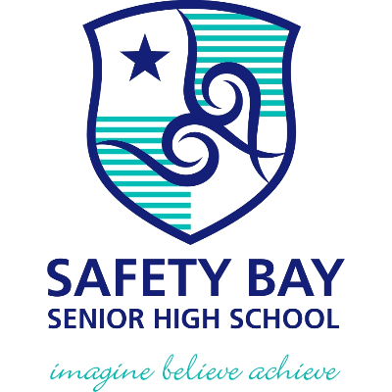 |  | SAFETY BAY SENIOR HIGH SCHOOL  Assessment Outline Report: 2022  Assessment Outline: 2022 Year 12 ATAR Chemistry  Course: Chemistry  Unit: ATCHE
Assessment Type | Weightings  (syllabus) |  | % Weight | When | Task Description and Content |  | Max Score
Practical assessment | 14.0% |  | 7 | Term 1, Week 8 | 3  Practical Test #1  Volumetric Analysis |  | 100.0
 |  |  | 7 | Term 3, Week 1 | 8  Practical Test #2  Empirical formulae |  | 100.0
Investigations | 6.0% |  | 6 | Term 2, Week 1 | 5  Investigation #1  Construction and analysis of electrochemical cells |  | 100.0
Assignments and class work | 10.0% |  | 5 | Term 2, Week 2 | 4  Extended Response #1  Principles in use of electrochemical cells in society |  | 100.0
 |  |  | 5 | Term 3, Week 6 | 10  Extended Response #2  Amino acids, proteins, soaps, detergents and alcohols |  | 100.0
Tests and examinations | 70.0% |  | 4 | Term 1, Week 4 | 1  Test #1 Rates and Equilibrium  Rates and Equilibrium |  | 100.0
 |  |  | 4 | Term 1, Week 9 | 2  Test #2 Acids and Bases  Acids and Bases |  | 100.0
 |  |  | 4 | Term 2, week 3 | 6  Test #3  Reduction and Oxidation |  | 100.0
 |  |  | 20 | Term 2, Week 6 | 7 (School Examination)  Semester 1 Examination  Unit 3 content only |  | 100.0
 |  |  | 4 | Term 3, Week 2 | 9  Test #4  Organic Chemistry |  | 100.0
 |  |  | 4 | Term 3, Week 7 | 11  Test # 5  Chemical Synthesis/ Polymers |  | 100.0
 |  |  | 30 | Term 3/4, Holidays | 12 (School Examination)  Semester 2 Examination  Unit 3 and 4 content (Mock WACE examination) |  | 100.0
Total |  |  | 100

